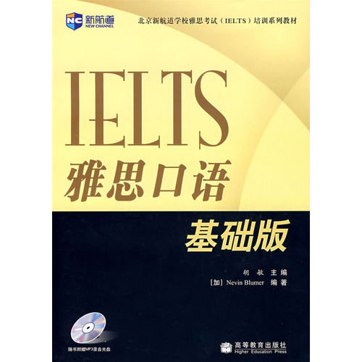
Introduction
IELTS (Basic Edition) is one of the "New Channel School IELTS series is the basis of spoken language textbooks written specifically for the vast number of IELTS candidates.
IELTS exam after the change, the increasing emphasis on examining students' English communication ability in a variety of contexts. The three parts of the exam is the Deep, from the ordinary social to academic discussion of scenario reproduction, respectively, to examine the students from the living to communicate to the semi-formal discussion to the academic study of verbal ability. Many candidates are spoken by leaps and bounds in the short term, but the real high level of oral and can not be achieved overnight. The plot is not Kui step, so a thousand miles - to learn English, improve English speaking ability. Therefore, the book from the foundation heard start learning book designed to help students as they climbed to the peak of the IELTS exam, and where to plug in the banner of victory.
The largest features of the book is to listen to based on, I heard that combination. In fact, in the early stages of learning you want to oral communication as much as listening to English is very important. Many linguists suggested that students need before attempting to speak English widely listen to some of the relevant and meaningful dialogue. Therefore, this book combines the oral types of issues over the years IELTS often test, using the listen-before-mode, the use of scenarios and the topic will be a full course series. Through book learning, students found many related topics at the same time to improve speaking skills, efficient and pro forma, but also to understand the background and cultural knowledge, and truly the perfect combination of exam-oriented training and language skills improve.

